Tugas Checkpoint 5

Nama : Labiba Adinda Zahwana
Kelas : C

Bagian 0
Field apa saja yang wajib ada agar automation bisa berjalan?
Field yang wajib ada agar automation SOAR dapat berjalan dengan benar adalah:
Field | Fungsi
src_ip | Mengidentifikasi sumber serangan atau attacker
rule_name | Menentukan jenis alert/insiden
event_count | Mengukur jumlah aktivitas mencurigakan
timestamp | Menentukan waktu kejadian
port_count | Digunakan untuk mendeteksi aktivitas port scanning

Contoh field utama pada payload:
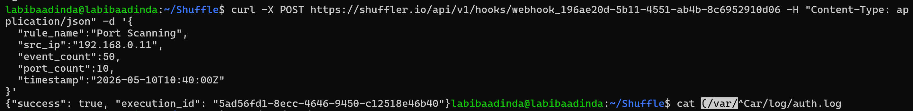
Field-field tersebut diperlukan karena workflow membutuhkan data untuk:
- identifikasi attacker,
- klasifikasi jenis serangan,
- menghitung severity,
- menentukan keputusan response otomatis,
- dan membuat audit trail insiden.
Tanpa field penting seperti src_ip, rule_name, atau event_count, automation dapat gagal berjalan atau menghasilkan false positive pada proses response.
Bagian 1
Apa risiko jika validasi input diabaikan pada SOAR?
Jika validasi input diabaikan pada SOAR, maka workflow automation dapat memproses payload yang salah, tidak lengkap, atau dimanipulasi sehingga menyebabkan kesalahan response keamanan.
Beberapa risiko yang dapat terjadi:
Risiko | Dampak
False Positive | IP normal atau legitimate dapat terblokir
False Negative | Serangan asli tidak terdeteksi
Payload Manipulation | Attacker dapat mengirim alert palsu
Automation Abuse | Workflow dipicu secara tidak sah
Service Disruption | Blocking otomatis dapat mengganggu layanan
Severity Misclassification | Tingkat ancaman salah dihitung
Audit Trail Tidak Valid | Evidence dan logging menjadi tidak akurat

Bagian 2
Mengapa enrichment penting sebelum blocking otomatis?
Enrichment penting karena membantu workflow memahami konteks alert sebelum mengambil keputusan automated response.
Tanpa enrichment:
- IP internal dapat terblokir secara tidak sengaja
- whitelist tidak dikenali
- severity ancaman tidak akurat
- false positive meningkat
- layanan legitimate dapat terganggu
Contohnya, jika IP berasal dari server internal monitoring tetapi tidak dilakukan enrichment, workflow dapat salah menganggap aktivitas tersebut sebagai serangan dan melakukan blocking otomatis.
Dengan enrichment:
- decision making lebih akurat
- false positive berkurang
- blocking lebih aman
- automation lebih reliable
- response dapat disesuaikan dengan tingkat ancaman

Bagian 3
Mengapa blocking sebaiknya bersifat sementara?
Blocking sebaiknya bersifat sementara karena automated response memiliki risiko false positive dan dapat memblokir IP legitimate secara tidak sengaja.
Jika blocking dilakukan permanen:
- user valid dapat kehilangan akses
- layanan legitimate dapat terganggu
- recovery membutuhkan intervensi manual
- risiko operational disruption meningkat
Blocking sementara memungkinkan:
- attacker dihentikan sementara
- sistem tetap aman
- rollback lebih mudah dilakukan
- cooldown automation diterapkan
- false positive dapat diminimalkan
Contohnya, jika IP internal atau user legitimate salah terdeteksi sebagai brute force attacker, maka temporary block akan otomatis berakhir setelah periode tertentu sehingga akses dapat kembali normal tanpa tindakan manual.

Bagian 4
Apa risiko melakukan block tanpa klasifikasi severity?
Melakukan blocking tanpa klasifikasi severity dapat menyebabkan automation memblokir aktivitas yang sebenarnya tidak berbahaya atau legitimate.
Beberapa risiko yang dapat terjadi:
Risiko | Dampak
False Positive | Traffic normal ikut terblokir
Gangguan Layanan | User legitimate kehilangan akses
Blocking Berlebihan | Scanning ringan dianggap serangan serius
Operational Disruption | Monitoring atau health check internal gagal
Overreaction Automation | Semua scanning diperlakukan sama
Alert Fatigue | Terlalu banyak block/notifikasi

Contohnya, scanning terhadap port web umum seperti 80 atau 443 belum tentu berbahaya karena dapat berasal dari monitoring tool atau crawler normal. Namun scanning terhadap port sensitif seperti SSH (22) atau RDP (3389) memiliki risiko lebih tinggi sehingga lebih layak untuk diblokir otomatis.
Karena itu klasifikasi severity penting agar response automation tetap proporsional, akurat, dan tidak mengganggu operasional sistem.

Bagian 5
Dampak operasional jika automation tidak memiliki rollback?
Jika automation tidak memiliki rollback atau mekanisme unblock, maka kesalahan response dapat menyebabkan gangguan operasional yang serius.
Beberapa dampak yang dapat terjadi:
Dampak | Penjelasan
User Legitimate Terkunci | User valid tidak dapat mengakses layanan
Downtime Operasional | Sistem internal dapat terblokir
Gangguan Monitoring | Monitoring/health check gagal berjalan
Recovery Lambat | Harus dilakukan manual oleh administrator
Risiko False Positive Tinggi | Kesalahan block sulit dipulihkan
Gangguan Layanan Produksi | Service penting dapat tidak dapat diakses

Contohnya, jika IP administrator internal salah terdeteksi sebagai attacker dan diblokir permanen tanpa rollback, maka administrator tidak dapat mengakses server hingga firewall dibuka secara manual.
Karena itu rollback sangat penting agar:
- automation tetap aman,
- recovery lebih cepat,
- false positive dapat dipulihkan,
- dan operasional sistem tetap stabil.

Tugas MINI Project
Diagram alur workflow
Webhook Alert
↓
Bagian 0 – Webhook Trigger
↓
Bagian 1 – Validation & Normalization
↓
Bagian 2 – Enrichment & Context Building
↓
Attack Classification
↙ ↘
Brute Force Port Scanning
↓ ↓
Block / Notify Notify / Monitor
↓ ↓
Safety Control & Rollback

Workflow
Terdapat dua workflow yang digunakan bruteforce dan port scanning
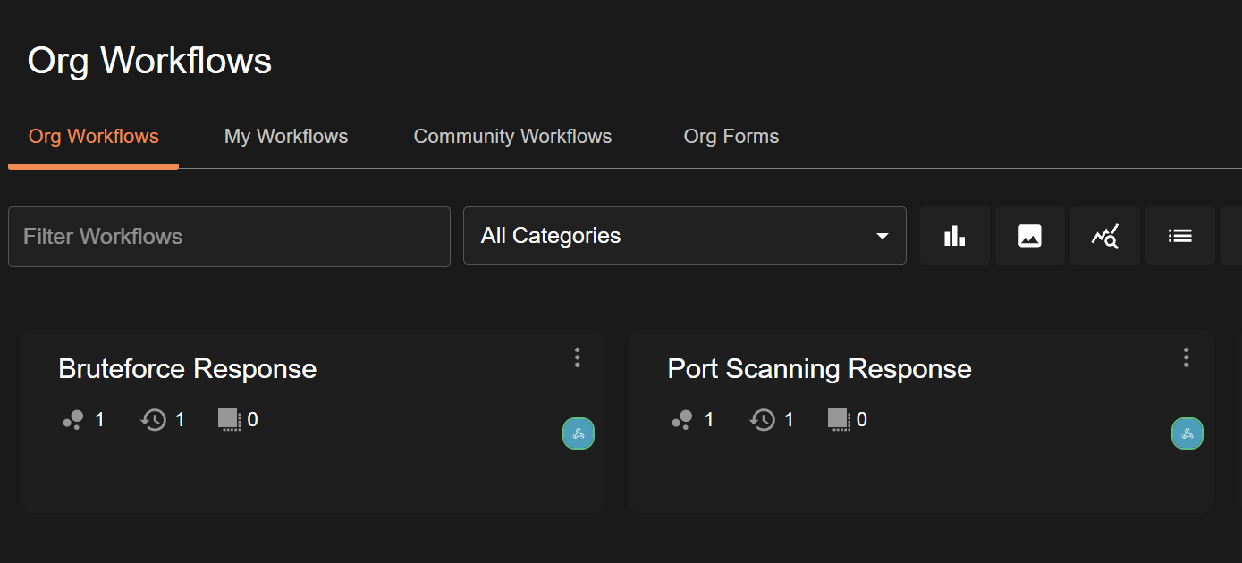

Workflow Port Scanning
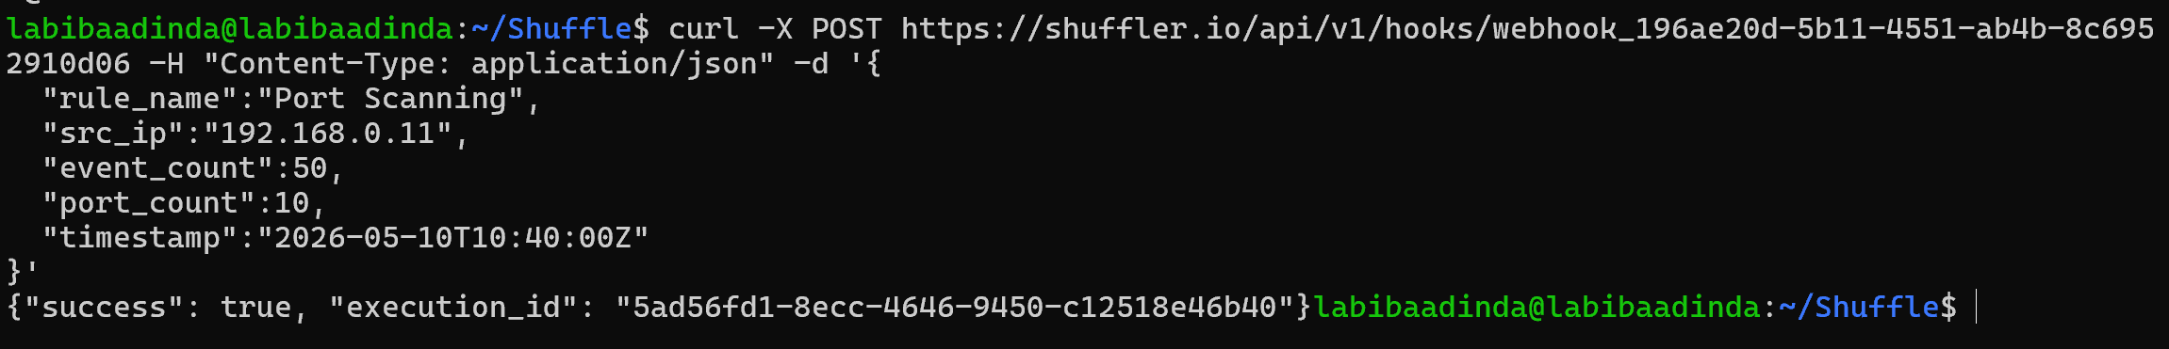
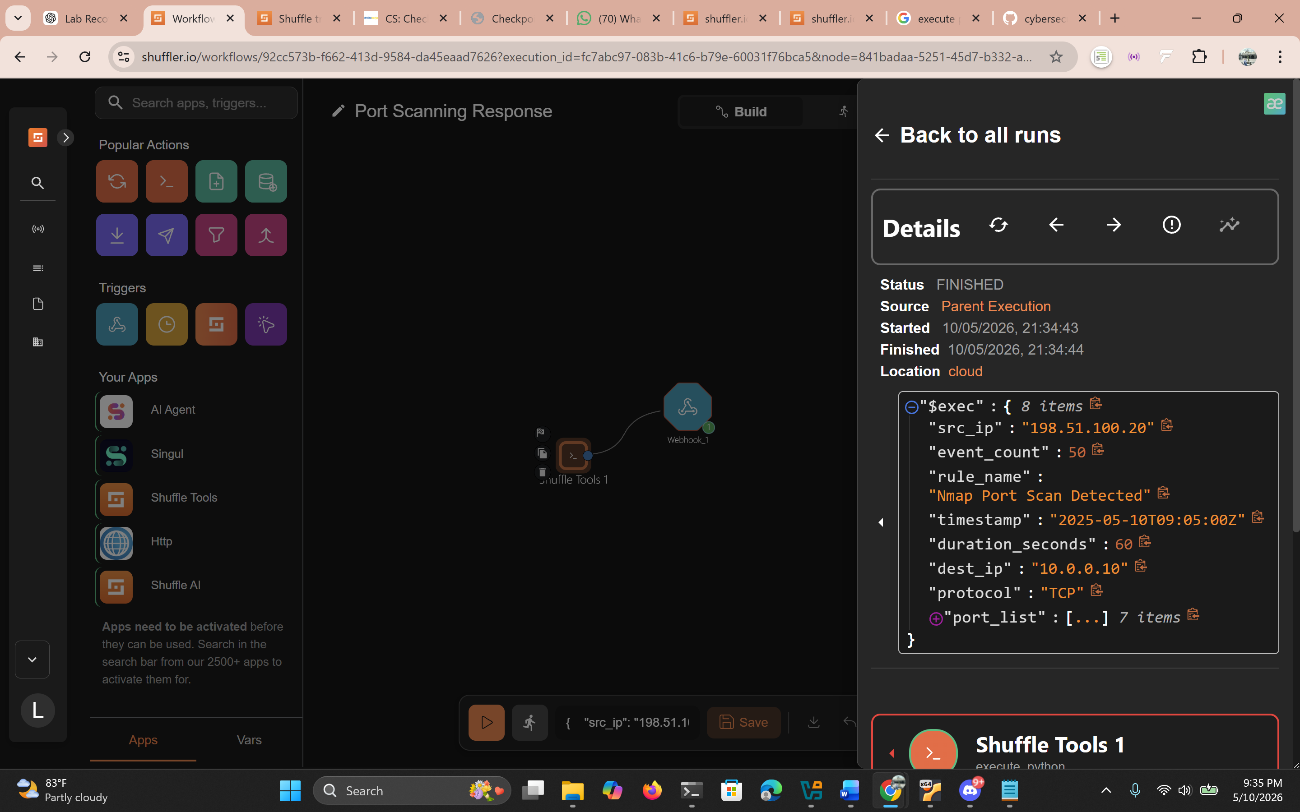
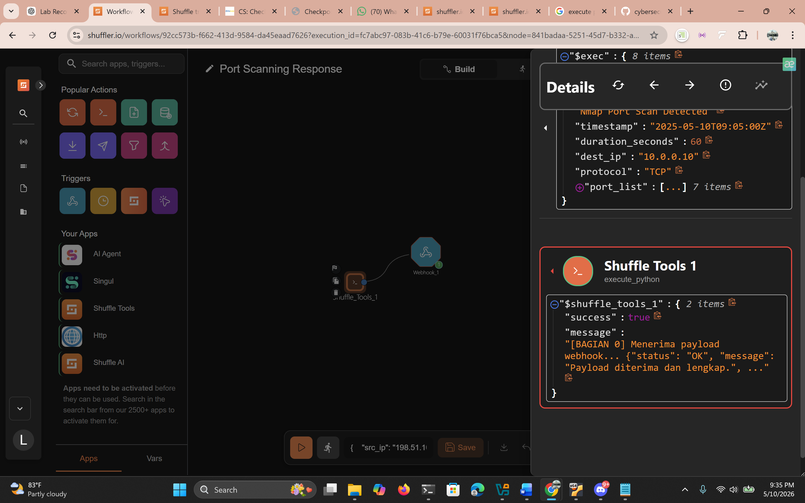
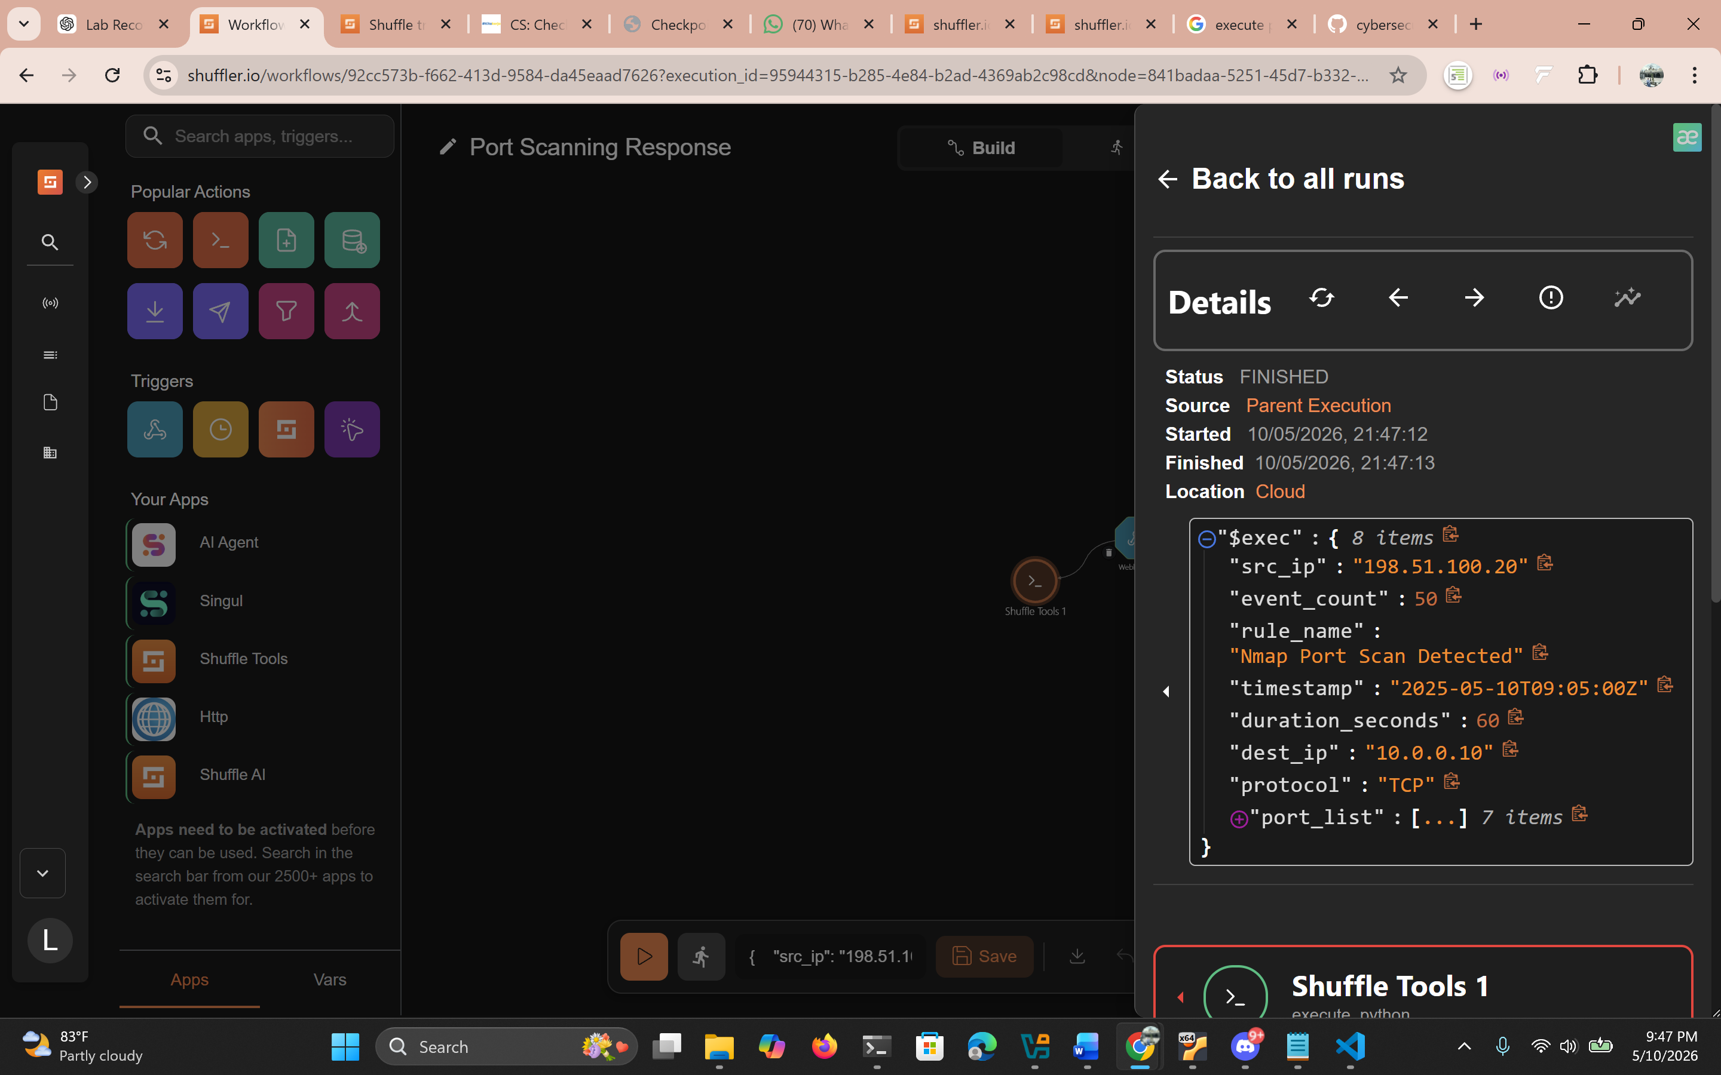
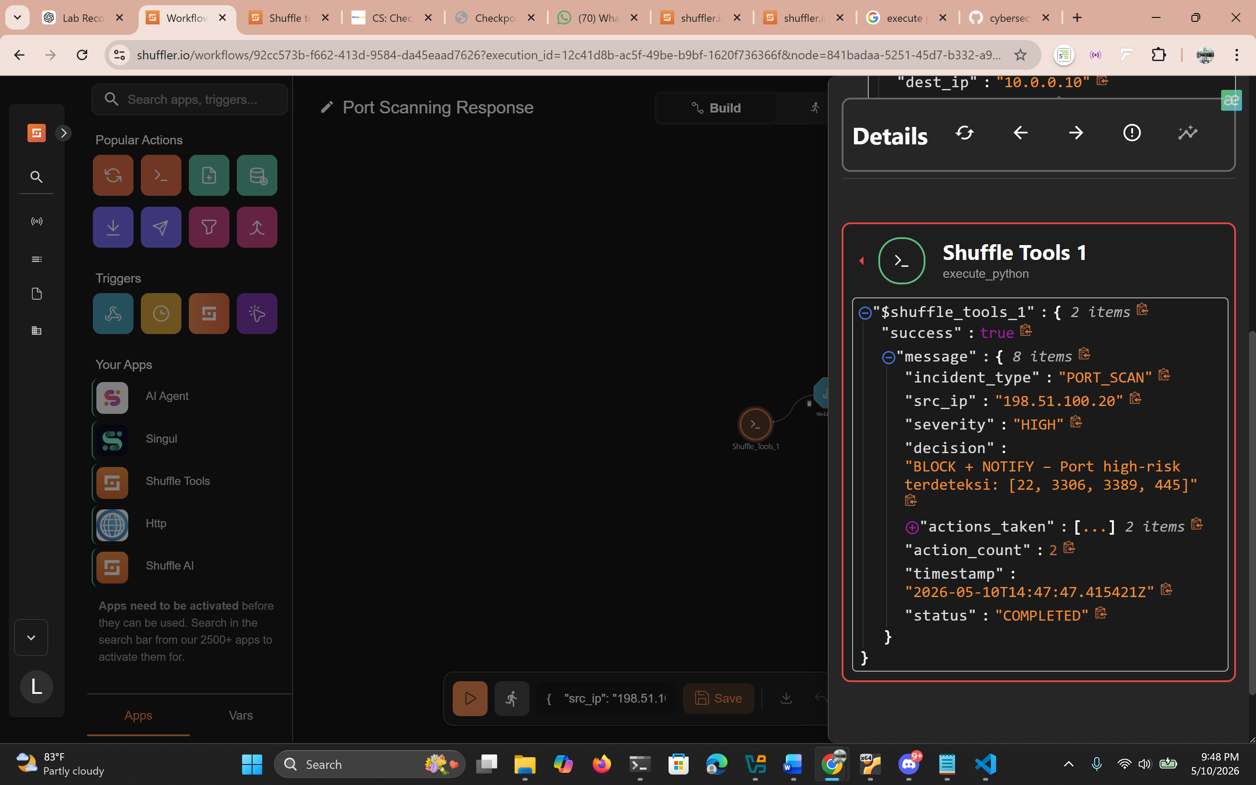

Workflow Brute Force
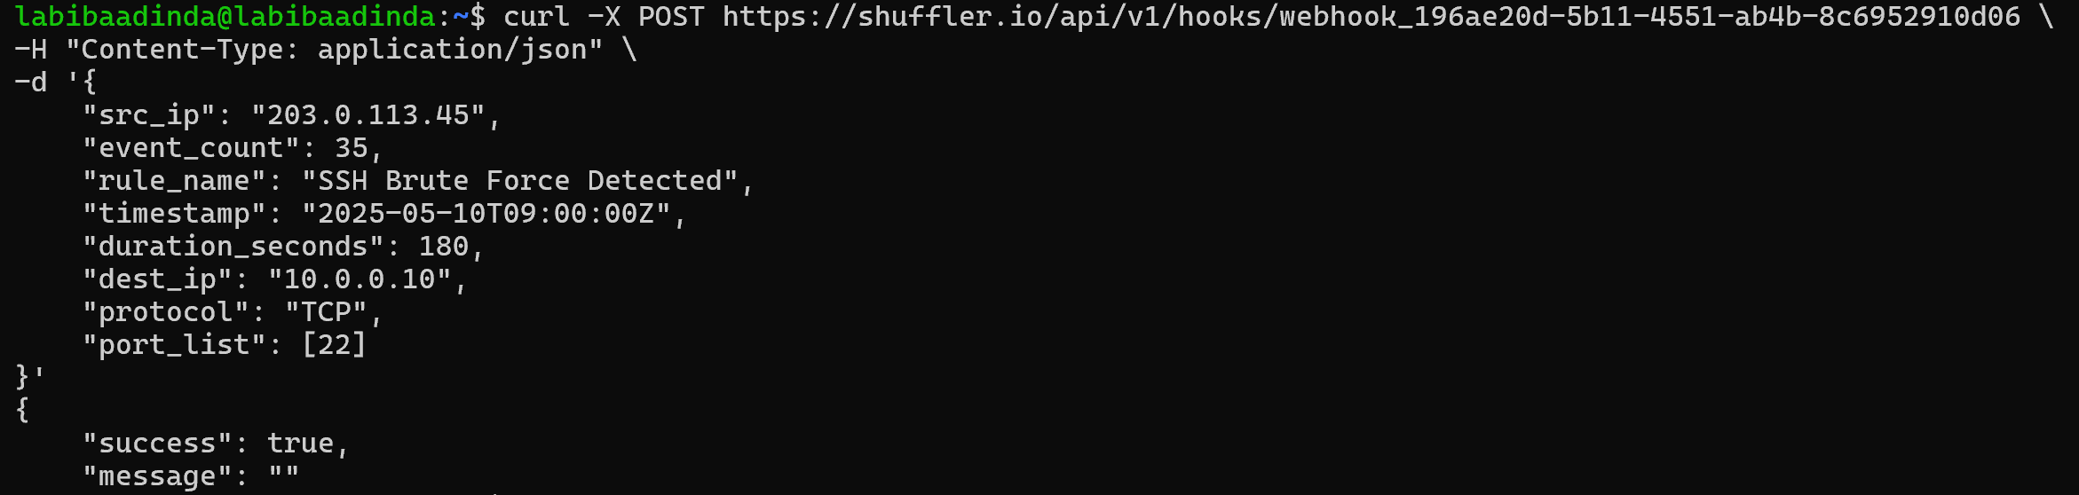
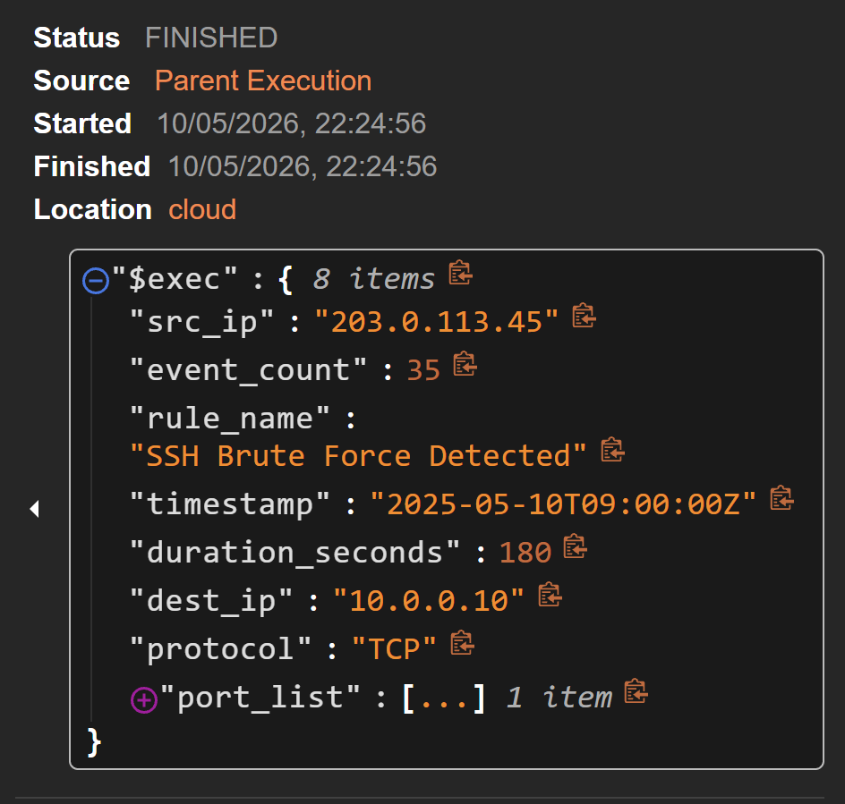
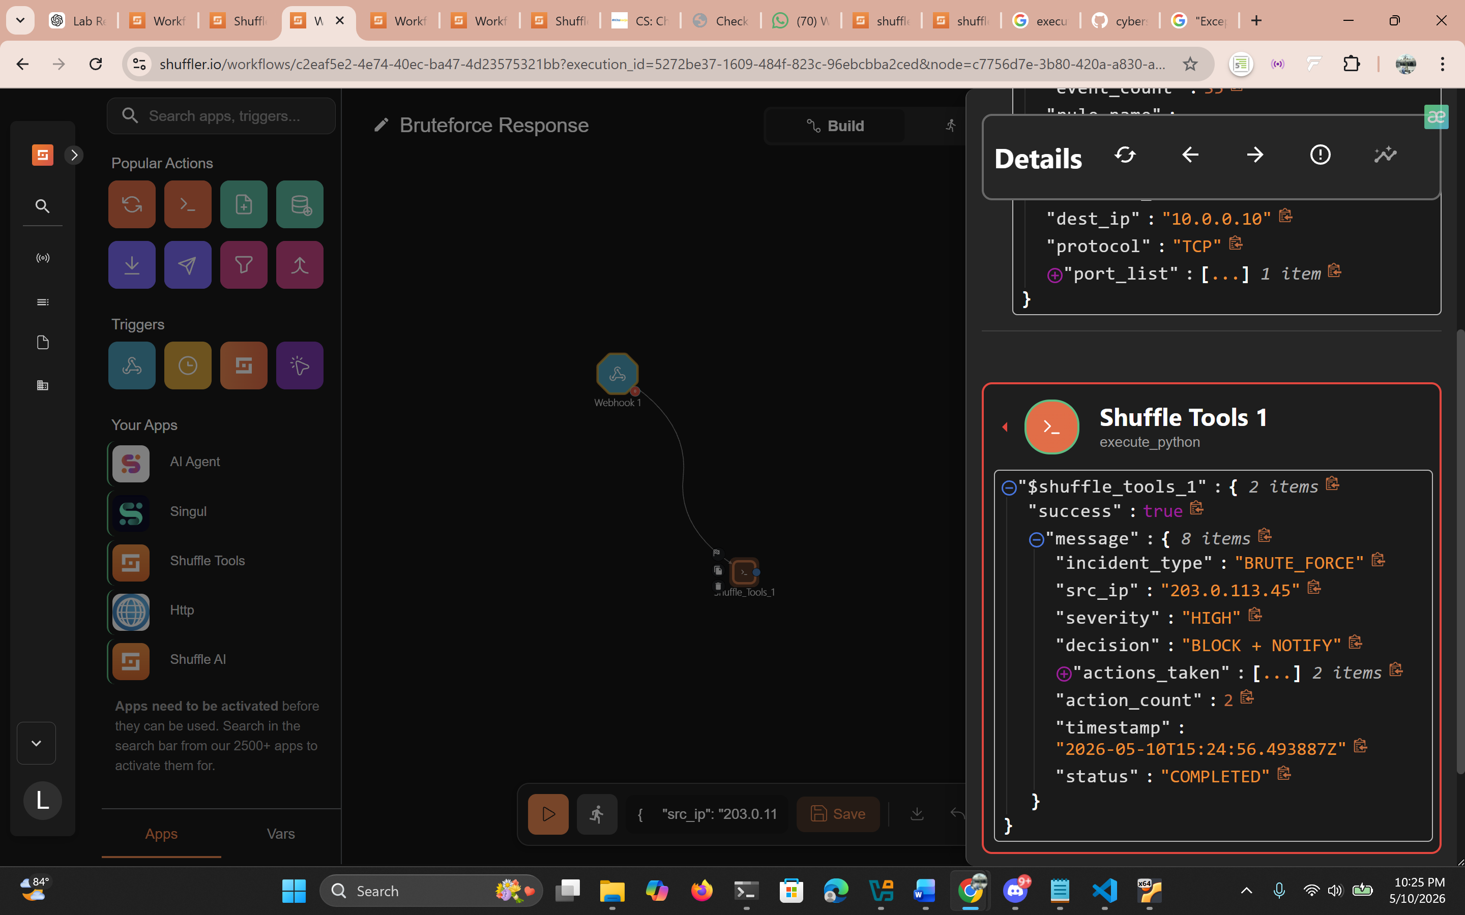

Python code yang digunakan di Shuffle
import json
import re
import subprocess
import datetime
import os

# ─────────────────────────────────────────────────────────────
# KONFIGURASI GLOBAL
# ─────────────────────────────────────────────────────────────

WHITELIST_IPS = [
"192.168.1.1",
"10.0.0.1",
"127.0.0.1",
"10.10.10.5",
]

INTERNAL_RANGES = [
"192.168.",
"10.",
"172.16.",
"172.17.",
"172.18.",
"172.19.",
"172.20.",
"172.21.",
"172.22.",
"172.23.",
"172.24.",
"172.25.",
"172.26.",
"172.27.",
"172.28.",
"172.29.",
"172.30.",
"172.31.",
]

EVIDENCE_LOG_PATH = "/var/log/shuffle_ir_evidence.log"
COOLDOWN_FILE = "/tmp/shuffle_blocked_ips.json"
BLOCK_DURATION_MINUTES = 30

HIGH_RISK_PORTS = [22, 3389, 445, 3306, 5432, 6379, 27017]
LOW_RISK_PORTS = [80, 443, 8080, 8443]

def section_0_webhook_trigger(raw_payload: str) -> dict:
"""
Tujuan : Memastikan Shuffle menerima alert dan payload dapat di-parse.
Input : raw_payload (string JSON dari webhook)
Output : dict parsed alert atau error

Di Shuffle, gunakan:
raw_payload = "{{$exec}}" ← execution body dari webhook trigger
"""

try:
if isinstance(raw_payload, dict):
alert = raw_payload
else:
alert = json.loads(raw_payload)
except (json.JSONDecodeError, TypeError) as e:
result = {
"status": "ERROR",
"message": f"Payload tidak valid / bukan JSON: {str(e)}",
"raw": str(raw_payload)
}

return result

required_fields = ["src_ip", "event_count", "rule_name"]
missing = [f for f in required_fields if f not in alert]

if missing:
result = {
"status": "INCOMPLETE",
"message": f"Field wajib tidak ditemukan: {missing}",
"alert": alert
}

return result

result = {
"status": "OK",
"message": "Payload diterima dan lengkap.",
"alert": alert
}

return result

# ─────────────────────────────────────────────────────────────
# BAGIAN 1 – NORMALISASI & VALIDASI INPUT
# ─────────────────────────────────────────────────────────────

def section_1_normalize_validate(alert: dict) -> dict:
"""
Tujuan : Mencegah automation berjalan dari data tidak valid / manipulatif.
Input : alert dict (output Bagian 0)
Output : normalized alert atau error

Di Shuffle:
alert = {{$exec.alert}} ← dari output node Bagian 0
"""

errors = []

# Validasi src_ip
src_ip = str(alert.get("src_ip", "")).strip()
ip_pattern = re.compile(
r'^(\d{1,3}\.){3}\d{1,3}$'
)
if not ip_pattern.match(src_ip):
errors.append(f"src_ip tidak valid: '{src_ip}'")
else:
parts = src_ip.split(".")
if any(int(p) > 255 for p in parts):
errors.append(f"src_ip oktet out of range: '{src_ip}'")

# Validasi event_count
try:
event_count = int(alert.get("event_count", -1))
if event_count < 0:
errors.append("event_count harus >= 0")
except (ValueError, TypeError):
errors.append("event_count bukan integer")
event_count = 0

# Validasi rule_name
rule_name = str(alert.get("rule_name", "")).strip()
if not rule_name:
errors.append("rule_name kosong")

# Normalisasi timestamp
timestamp = alert.get("timestamp", datetime.datetime.utcnow().isoformat() + "Z")

# Normalisasi opsional: port_list
port_list = alert.get("port_list", [])
if isinstance(port_list, str):
try:
port_list = json.loads(port_list)
except Exception:
port_list = []

if errors:
result = {
"status": "INVALID",
"errors": errors,
"original_alert": alert
}

return result

normalized = {
"src_ip": src_ip,
"event_count": event_count,
"rule_name": rule_name,
"timestamp": timestamp,
"port_list": port_list,
"duration_seconds": alert.get("duration_seconds", 300),
"dest_ip": alert.get("dest_ip", ""),
"protocol": alert.get("protocol", "").upper(),
}

result = {
"status": "VALID",
"normalized_alert": normalized
}

return result

# ─────────────────────────────────────────────────────────────
# BAGIAN 2 – ENRICHMENT & CONTEXT BUILDING
# ─────────────────────────────────────────────────────────────

def section_2_enrichment(normalized_alert: dict) -> dict:
"""
Tujuan : Menambahkan konteks sebelum keputusan response diambil.
Input : normalized_alert (output Bagian 1)
Output : enriched context

Di Shuffle:
normalized_alert = {{$exec.normalized_alert}}
"""

src_ip = normalized_alert["src_ip"]
event_count = normalized_alert["event_count"]
rule_name = normalized_alert["rule_name"].lower()
port_list = normalized_alert.get("port_list", [])

# Cek apakah IP internal
is_internal = any(src_ip.startswith(prefix) for prefix in INTERNAL_RANGES)

# Cek whitelist
is_whitelisted = src_ip in WHITELIST_IPS

# Severity hint berdasarkan rule + event count
if event_count >= 50:
severity_hint = "CRITICAL"
elif event_count >= 20:
severity_hint = "HIGH"
elif event_count >= 10:
severity_hint = "MEDIUM"
else:
severity_hint = "LOW"

# Override severity untuk whitelist / internal
if is_whitelisted or is_internal:
severity_hint = "INFO"

# Deteksi tipe serangan berdasarkan rule_name
if any(k in rule_name for k in ["brute", "ssh", "login", "auth", "fail"]):
attack_type = "BRUTE_FORCE"
elif any(k in rule_name for k in ["scan", "recon", "probe", "sweep", "nmap"]):
attack_type = "PORT_SCAN"
else:
attack_type = "UNKNOWN"

# Analisis port risk (untuk scanning)
high_risk_detected = [p for p in port_list if int(p) in HIGH_RISK_PORTS]
low_risk_only = all(int(p) in LOW_RISK_PORTS for p in port_list) if port_list else False

context = {
"src_ip": src_ip,
"is_internal": is_internal,
"is_whitelisted": is_whitelisted,
"severity_hint": severity_hint,
"attack_type": attack_type,
"high_risk_ports_detected": high_risk_detected,
"low_risk_only": low_risk_only,
"event_count": event_count,
"port_count": len(port_list),
"enrichment_time": datetime.datetime.utcnow().isoformat() + "Z",
"normalized_alert": normalized_alert
}

return context

# ─────────────────────────────────────────────────────────────
# BAGIAN 3 – PLAYBOOK RESPONSE BRUTE FORCE
# ─────────────────────────────────────────────────────────────

def section_3_bruteforce_response(context: dict, use_ufw: bool = False) -> dict:
"""
Tujuan : Otomasi response untuk brute force login.
Logic : event_count >= 20 dalam <= 5 menit AND bukan whitelist.
Input : context (output Bagian 2), use_ufw (True = eksekusi UFW)
Output : response report

Di Shuffle:
context = {{$exec}} ← full context dari Bagian 2
use_ufw = False ← set True jika ingin blokir nyata
"""

src_ip = context["src_ip"]
event_count = context["event_count"]
is_whitelisted = context["is_whitelisted"]
severity = context["severity_hint"]
duration_s = context["normalized_alert"].get("duration_seconds", 300)
rule_name = context["normalized_alert"]["rule_name"]

actions_taken = []
decision = ""

# ── Safety gate ──────────────────────────────────────────
if is_whitelisted:
decision = "SKIP – IP ada di whitelist"
result = _build_response_report("BRUTE_FORCE", src_ip, decision, actions_taken, severity)

return result

if context["is_internal"]:
decision = "NOTIFY_ONLY – IP internal, tidak diblokir"
actions_taken.append(_notify(src_ip, rule_name, severity, note="Internal IP, blokir dilewati"))
result = _build_response_report("BRUTE_FORCE", src_ip, decision, actions_taken, severity)

return result

# ── Decision logic ────────────────────────────────────────
# event_count >= 20 dalam <= 5 menit (300 detik)
if event_count >= 20 and duration_s <= 300:
decision = "BLOCK + NOTIFY"

# Cooldown check
if _is_in_cooldown(src_ip):
decision = "SKIP – Sudah dalam cooldown, tidak duplikat blokir"
result = _build_response_report("BRUTE_FORCE", src_ip, decision, actions_taken, severity)

return result

# Blokir sementara
block_result = _block_ip(src_ip, use_ufw=use_ufw, reason="BruteForce")
actions_taken.append(block_result)

# Catat cooldown
_add_to_cooldown(src_ip)

# Notifikasi
actions_taken.append(_notify(src_ip, rule_name, severity))

elif event_count >= 10:
decision = "NOTIFY_ONLY – event_count sedang, monitoring"
actions_taken.append(_notify(src_ip, rule_name, severity, note="Threshold rendah, hanya notify"))

else:
decision = "LOG_ONLY – event_count rendah"

result = _build_response_report("BRUTE_FORCE", src_ip, decision, actions_taken, severity)

return result

# ─────────────────────────────────────────────────────────────
# BAGIAN 4 – PLAYBOOK RESPONSE PORT SCANNING
# ─────────────────────────────────────────────────────────────

def section_4_portscan_response(context: dict, use_ufw: bool = False) -> dict:
"""
Tujuan : Menangani aktivitas reconnaissance / port scanning.
Logic : port_count >= 5 ATAU event_count tinggi.
Input : context (output Bagian 2)
Output : response report

Di Shuffle:
context = {{$exec}}
use_ufw = False
"""

src_ip = context["src_ip"]
event_count = context["event_count"]
port_count = context["port_count"]
is_whitelisted = context["is_whitelisted"]
severity = context["severity_hint"]
high_risk_ports = context["high_risk_ports_detected"]
low_risk_only = context["low_risk_only"]
rule_name = context["normalized_alert"]["rule_name"]

actions_taken = []
decision = ""

# ── Safety gate ──────────────────────────────────────────
if is_whitelisted or context["is_internal"]:
decision = "SKIP – Whitelisted / IP internal"
result = _build_response_report("PORT_SCAN", src_ip, decision, actions_taken, severity)

return result

# ── Severity classification ───────────────────────────────
triggered = (port_count >= 5) or (event_count >= 30)

if triggered:
if high_risk_ports:
# High-risk: SSH, RDP, DB ports terdeteksi → BLOCK
decision = f"BLOCK + NOTIFY – Port high-risk terdeteksi: {high_risk_ports}"
severity = "HIGH"

if not _is_in_cooldown(src_ip):
block_result = _block_ip(src_ip, use_ufw=use_ufw, reason="PortScan-HighRisk")
actions_taken.append(block_result)
_add_to_cooldown(src_ip)
else:
decision += " (sudah dalam cooldown)"

actions_taken.append(_notify(src_ip, rule_name, severity, note=f"Port kritis: {high_risk_ports}"))

elif low_risk_only:
# Low-risk: hanya HTTP/HTTPS → hanya notify
decision = "NOTIFY_ONLY – Hanya port low-risk (80/443)"
severity = "LOW"
actions_taken.append(_notify(src_ip, rule_name, severity, note="Scan ke port web saja"))

else:
# Mixed ports → notify + monitor
decision = "NOTIFY + MONITOR – Port campuran"
severity = "MEDIUM"
actions_taken.append(_notify(src_ip, rule_name, severity, note="Port campuran, perlu monitoring"))

else:
decision = "LOG_ONLY – Ambang batas scanning belum tercapai"

result = _build_response_report("PORT_SCAN", src_ip, decision, actions_taken, severity)

return result

# ─────────────────────────────────────────────────────────────
# BAGIAN 5 – SAFETY CONTROLS (Whitelist, Cooldown, Rollback)
# ─────────────────────────────────────────────────────────────

def section_5_safety_controls(action: str, target_ip: str, use_ufw: bool = False) -> dict:
"""
Tujuan : Manajemen keamanan automation (whitelist, cooldown, rollback/unblock).
Input :
action = "add_whitelist" | "remove_whitelist" |
"unblock" | "check_cooldown" | "clear_cooldown"
target_ip = IP yang ditarget
use_ufw = True jika ingin unblock nyata via UFW

Di Shuffle, buat node dengan parameter:
action = "{{$exec.action}}"
target_ip = "{{$exec.target_ip}}"

Contoh payload webhook untuk trigger rollback:
{"action": "unblock", "target_ip": "1.2.3.4"}
"""

result = {"action": action, "target_ip": target_ip, "status": ""}

if action == "add_whitelist":
if target_ip not in WHITELIST_IPS:
WHITELIST_IPS.append(target_ip)
result["status"] = f"{target_ip} ditambahkan ke whitelist (runtime)"
else:
result["status"] = f"{target_ip} sudah ada di whitelist"

elif action == "remove_whitelist":
if target_ip in WHITELIST_IPS:
WHITELIST_IPS.remove(target_ip)
result["status"] = f"{target_ip} dihapus dari whitelist"
else:
result["status"] = f"{target_ip} tidak ada di whitelist"

elif action == "unblock":
unblock_result = _unblock_ip(target_ip, use_ufw=use_ufw)
_remove_from_cooldown(target_ip)
result["status"] = unblock_result
result["rollback"] = True

elif action == "clear_cooldown":
_remove_from_cooldown(target_ip)
result["status"] = f"Cooldown untuk {target_ip} dihapus"

else:
result["status"] = f"Action tidak dikenal: {action}"

return result

# ─────────────────────────────────────────────────────────────
# HELPER FUNCTIONS (dipakai di semua bagian)
# ─────────────────────────────────────────────────────────────

def _block_ip(ip: str, use_ufw: bool = False, reason: str = "") -> dict:
"""Blokir IP via UFW atau dummy log."""
timestamp = datetime.datetime.utcnow().isoformat() + "Z"

if use_ufw:
try:
cmd = ["sudo", "ufw", "deny", "from", ip, "to", "any"]
subprocess.run(cmd, check=True, capture_output=True, text=True)
status = f"UFW: IP {ip} diblokir ({reason})"
except subprocess.CalledProcessError as e:
status = f"UFW ERROR: {e.stderr}"
else:
# Dummy mode – cocok untuk testing di Shuffle tanpa sudo
status = f"[DUMMY] Block IP {ip} – alasan: {reason}"

action = {
"action": "BLOCK",
"ip": ip,
"reason": reason,
"mode": "ufw" if use_ufw else "dummy",
"status": status,
"timestamp": timestamp,
"block_until": (
datetime.datetime.utcnow() +
datetime.timedelta(minutes=BLOCK_DURATION_MINUTES)
).isoformat() + "Z"
}

return action

def _unblock_ip(ip: str, use_ufw: bool = False) -> str:
"""Rollback: hapus blokir IP."""
if use_ufw:
try:
cmd = ["sudo", "ufw", "delete", "deny", "from", ip, "to", "any"]
subprocess.run(cmd, check=True, capture_output=True, text=True)
return f"UFW: Blokir {ip} dihapus (rollback)"
except subprocess.CalledProcessError as e:
return f"UFW unblock ERROR: {e.stderr}"
else:
return f"[DUMMY] Unblock IP {ip} berhasil"

def _notify(ip: str, rule: str, severity: str, note: str = "") -> dict:
"""Simulasi notifikasi (print / bisa diteruskan ke Shuffle HTTP node)."""
msg = {
"action": "NOTIFY",
"channel": "shuffle_notification",
"severity": severity,
"ip": ip,
"rule": rule,
"note": note,
"timestamp": datetime.datetime.utcnow().isoformat() + "Z",
"message": f"[{severity}] Insiden dari {ip} – {rule}. {note}"
}

return msg

def _is_in_cooldown(ip: str) -> bool:
"""Cek apakah IP masih dalam periode cooldown."""
try:
if not os.path.exists(COOLDOWN_FILE):
return False
with open(COOLDOWN_FILE, "r") as f:
data = json.load(f)
entry = data.get(ip)
if not entry:
return False
blocked_at = datetime.datetime.fromisoformat(entry["blocked_at"].replace("Z", ""))
elapsed = (datetime.datetime.utcnow() - blocked_at).total_seconds() / 60
return elapsed < BLOCK_DURATION_MINUTES
except Exception:
return False

def _add_to_cooldown(ip: str):
"""Tambahkan IP ke cooldown tracker."""
try:
data = {}
if os.path.exists(COOLDOWN_FILE):
with open(COOLDOWN_FILE, "r") as f:
data = json.load(f)
data[ip] = {"blocked_at": datetime.datetime.utcnow().isoformat() + "Z"}
with open(COOLDOWN_FILE, "w") as f:
json.dump(data, f, indent=2)
except Exception as e:
print(e)

def _remove_from_cooldown(ip: str):
"""Hapus IP dari cooldown tracker."""
try:
if not os.path.exists(COOLDOWN_FILE):
return
with open(COOLDOWN_FILE, "r") as f:
data = json.load(f)
data.pop(ip, None)
with open(COOLDOWN_FILE, "w") as f:
json.dump(data, f, indent=2)
except Exception as e:
print(e)

def _build_response_report(incident_type: str, src_ip: str,decision: str, actions: list, severity: str) -> dict:
"""Bangun response report standar."""
return {
"incident_type": incident_type,
"src_ip": src_ip,
"severity": severity,
"decision": decision,
"actions_taken": actions,
"action_count": len(actions),
"timestamp": datetime.datetime.utcnow().isoformat() + "Z",
"status": "COMPLETED"
}

# ─────────────────────────────────────────────────────────────
# CONTOH PAYLOAD SIMULASI (untuk testing lokal / Shuffle webhook)
# ─────────────────────────────────────────────────────────────

SAMPLE_BRUTE_FORCE_PAYLOAD = {
"src_ip": "203.0.113.45",
"event_count": 35,
"rule_name": "SSH Brute Force Detected",
"timestamp": "2025-05-10T09:00:00Z",
"duration_seconds": 180,
"dest_ip": "10.0.0.10",
"protocol": "TCP",
"port_list": [22]
}

SAMPLE_PORT_SCAN_PAYLOAD = {
"src_ip": "198.51.100.20",
"event_count": 50,
"rule_name": "Nmap Port Scan Detected",
"timestamp": "2025-05-10T09:05:00Z",
"duration_seconds": 60,
"dest_ip": "10.0.0.10",
"protocol": "TCP",
"port_list": [22, 80, 443, 3306, 3389, 8080, 445]
}

raw_payload = """$exec"""
# Bagian 0
payload = json.loads(raw_payload)
b0 = section_0_webhook_trigger(payload)
if b0["status"] != "OK":
print("Workflow dihentikan di Bagian 0.")
else:
# Bagian 1
b1 = section_1_normalize_validate(b0["alert"])
if b1["status"] != "VALID":
print("Workflow dihentikan di Bagian 1.")
else:
# Bagian 2
b2 = section_2_enrichment(b1["normalized_alert"])
# Bagian 3
if "Brute Force" in payload["rule_name"]:
b3 = section_3_bruteforce_response(b2, use_ufw=False)
print(json.dumps(b3, indent=2))
else:
b4 = section_4_portscan_response(b2, use_ufw=False)
print(json.dumps(b4, indent=2))

